1. For reading map data in the document
2. Sample data:

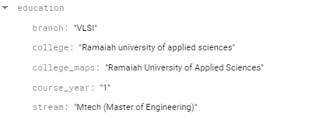



doc_ref = db.collection(u'cities').document(u'SF')  
  
doc = doc_ref.get()  
doc = doc.to_dict()

print(doc[‘branch’],doc[‘college’])

1. The above is reading particular data from map